Jibebe Internship 2022

# Progress report

Name: Adho Mamo

## Tasks completed last week

* [#7] Identification of parts used in making the robot car- Parts to be used in making the robot car was identified with its specification and what each part is used for.
* [#8] A drawing of the chassis for the robot car- The chassis that is the bottom chassis and the upper chassis was drawn using the AutoCAD software. The drawing also included the attachment parts.

**Arduino Mega**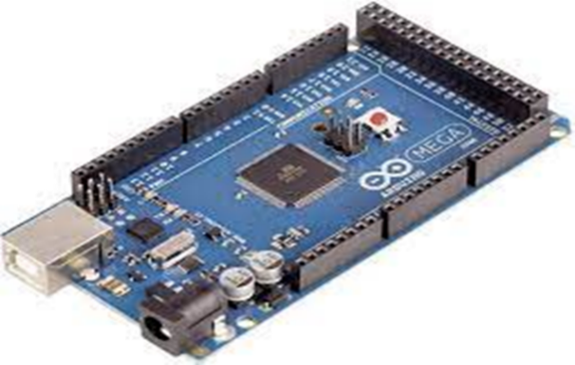

**DC motor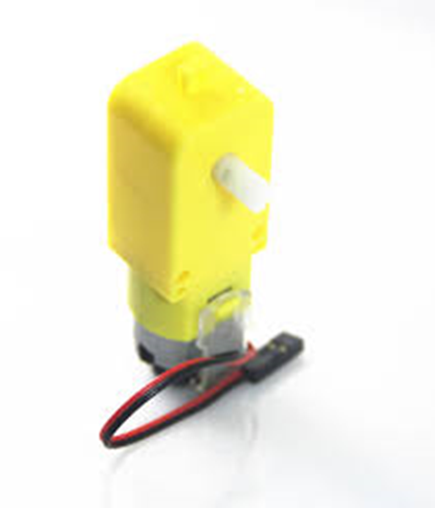 Ultrasonic sensor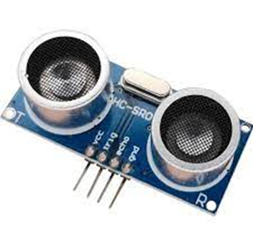 Motor shield**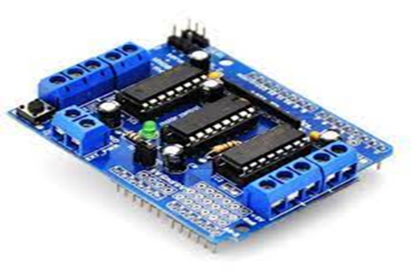

**Radio Frequency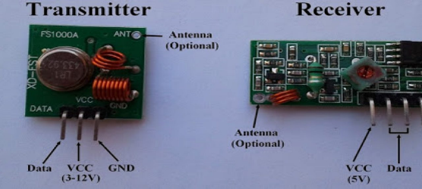 Buzzer**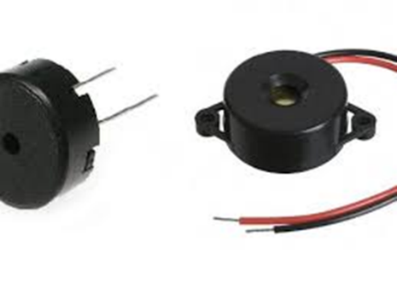

**Wheels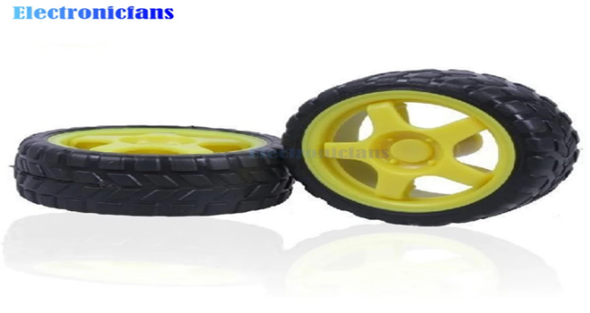 Servomotor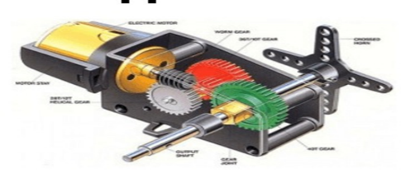 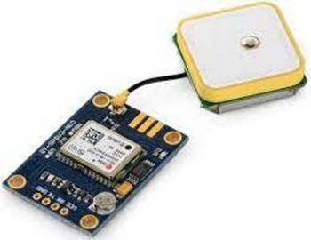GPS 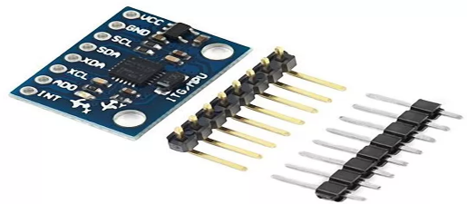Gyroscope**

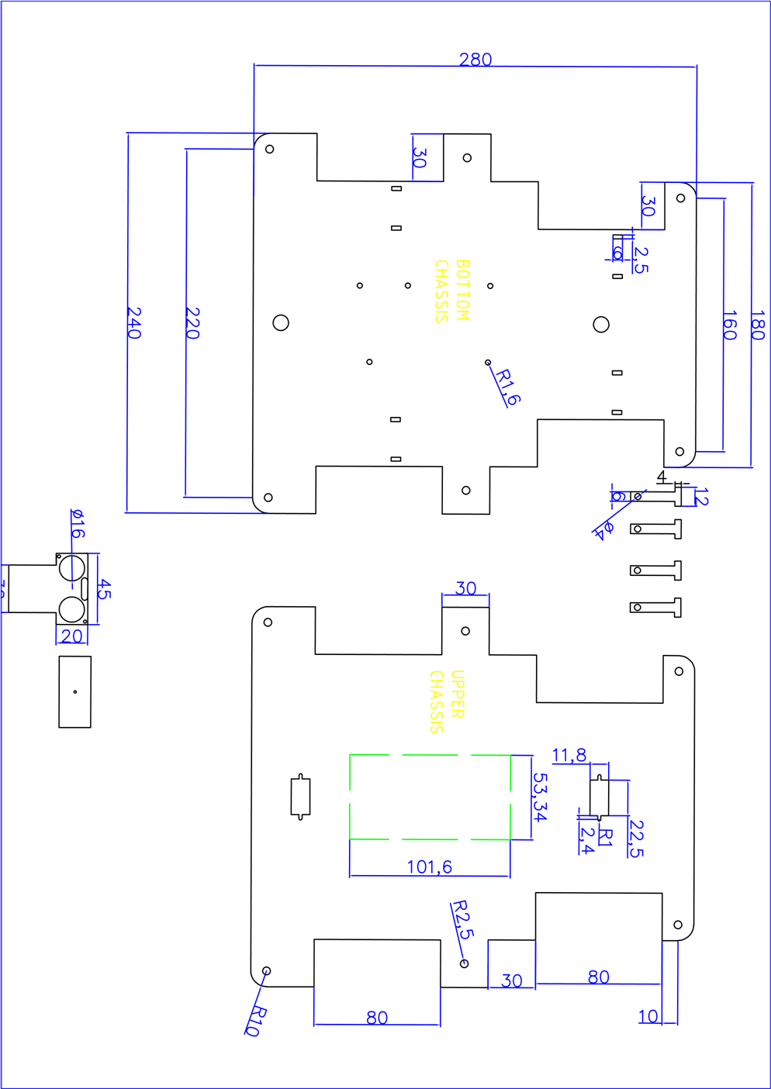

## Tasks in this week

* [#9] Circuit diagram of the robot car – draw the circuit diagram using the fritzing software.

## Timeline

|  |  |  |
| --- | --- | --- |
| Month | Intern week | Tasks |
| Jan |  |  |
| Week 1 | Identification of parts and drawing of the chassis diagram. |
| Week 2 | Circuit diagram and acquisition of parts. |
| Week 3 |  |
| Feb | Week 4 |  |
| Week 5 |  |
| Week 6 |  |
| Week 7 |  |